a
ANNEXURE “H”

CATALYTIC PROGRAMME MATRIX

PROJECT/PROGRAMME | Njoli Square Redevelopment is a project in the Njoli Precinct Plan programme
PROGRAMME MANAGER/DRIVER | EDTA / Amelia Büchner  Human Settlements / Schalk Potgieter
POLITICAL CHAMPION/REPORTING | MMCs: EDTA, HS
PROGRAMME OBJECTIVES | - Development of a Precinct Plan for the Njoli Hub and surrounds (including major road corridors leading to Njoli Square). The objective is to facilitate the creation of an urban development zone to incentivize mixed use intensification and densification over time by the private sector.  - Spatial transformation of the precinct  - Social transformation of the precinct  - Increased opportunity for job creation  - Development of a tourism and cultural precinct  - Improved quality of life in terms of mobility, social and recreational access for the residents of the area
PROGRAMME COMPONENTS YIELD (E.G. HOUSING UNITS, POS, JOB OPPORTUNITIES) | Project 1:  Development of Njoli Sqaure:  - Reconfiguration of the junction of Njoli and Daku Roads to accommodate traffic flow through a compact four-legged intersection.  - Accommodation of development components on the four quadrants surrounding the intersection.  - Promoting pedestrian accommodation through safe and controlled crossing points.  - Accommodating future IPTS stations on the approaches to the intersection and  - Accommodating all minibus-taxi operations in one facility at or close to the existing off-street facility.  Project 2:  Development of a Precinct plan:  - Defining a vision for the area  - Detailed analysis of the area (opportunities and constraints), services, facilities  - Urban design plan and development guidelines for the precinct  - List and locality of specific interventions and projects to be implemented.  - Business plan for the development concept
SPATIAL EXTENT OF PROGRAMME TO FIT URBAN NETWORK STRATEGY | Project within Integration Zone 1  Project central to Njoli Hub 1
SECTORAL INPUTS – INTERNAL
- Electricity and Energy | No bulks needed. Existing service will be re-aligned. This cost will be covered by NDPG
- Roads and Stormwater | IPTS is covering the designs and implementation of the roads and stormwater. Roads and Stormwater to provide input / comment on design.
- Economic Development | Ensure that the township economy is stimulated through the development
- Parks | Contribute to greening the precinct by planting trees.
- Environment | N/A
- Transportation | IPTS is covering the designs and implementation of the roads and stormwater. Co-ordinate the implementation.
- Housing | N/A; Private investors must cater for high density housing in their development
- Informal Settlements | N/A
- Land Use Planning | Assist for RFP for private sector investors; building plan and site development plan approval
- Development and Support | N/A
- Safety and Security | To take note of the development
- MBDA | N/A
- Other | N/A
SECTORAL INPUTS – EXTERNAL
- PRASA | Inform them of the development
- Transnet | N/A
- NMMU | Inform them of the development
- Business Chamber | Inform them of the development
- ACSA | N/A
- Dept. Arts and Culture | N/A
- SANRAL | N/A
- Dept. of Forestry | N/A
- DEDEA | Inform them of the development
- Public Works | Inform them of the development
- Human Settlements | Inform them of the development
- HDA | Inform them of the development and land is being made available for housing.
- Heritage | N/A
- Other | N/A
COMMUNITY INTERESTS | Yes, Public Participation is part of the project scope
BUDGET AND SOURCE | NDPG has indicated that they will consider funding the project once a breakdown of costs have been submitted.
- Total budget required | R50 000 000
- 2017/18 | -
- 2018/19 | R20 000 000
- 2019/20 | R20 000 000
- Budget shortfall | Depends on NDPG approval of budget
PROJECTED IMPLEMENTATION PERIOD | 5 years
IDP/BEPP LINKAGE/ALIGNMENT | BEPP Catalytic Project - Njoli Urban Hub Precinct
LINKAGES WITH OTHER EXISTING OR FUTURE PROJECTS (E.G. ZANEMVULA PART OF GERMAN PROJECT) | Physical linkage to/integration with the “Soweto and Sea Veeplaas LSDF” and Precinct Plan
PROJECT/PROGRAMME PROGRESS TO DATE | The project design was approved by Council 15 December 2015.
CHALLENGES | - The appointment of the Consulting Consortium to continue with the project.  - NDPG is awaiting a detailed breakdown of the project elements with a plan from NMBM on the project before funding is approved. IPTS is in the process of preparing this. It should be concluded by end February 2018.  - The appointment of consultants to prepare the precinct plan has taken 7 months.
NEXT STEP | - NMBM must submit a concept plan for Project 1 with a request for funding to NDPG. IPTS is in the process of preparing this. It should be concluded by end February 2018.  - The item to appoint consultants to prepare the precinct plan (project 2) will be presented to BAC on 26 Jan 2018. If approved proceed to appoint the Consultants.
RISKS | - Land invasion of the vacant land in and around Njoli. Mitigation: Keep the community informed through public participation. Request the ward Cllr to monitor the situation on the ground.  - The time it is taking to resolve the appointment of the consultants. Mitigation: alert as many senior staff as possible.  - The community is losing interest in the project because it to taking so long. Mitigation: Keep the community informed through public participation.  - Inflation is making the project un-affordable. Mitigation: ensure that there is no delays in getting funding and implementing the project.

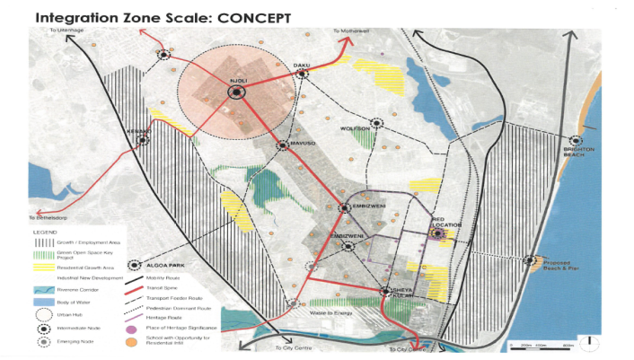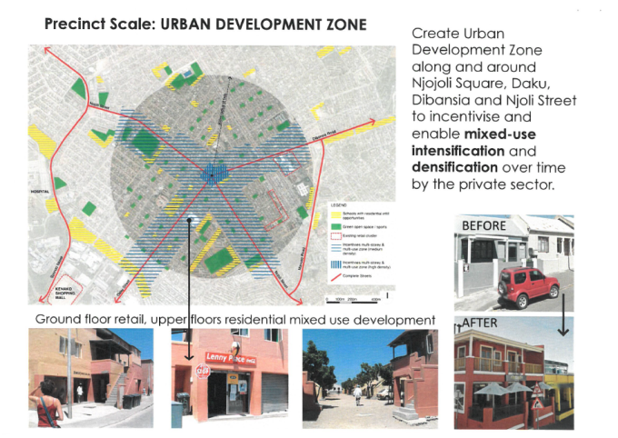

Arial view of project after 72 properties were acquired and demolished 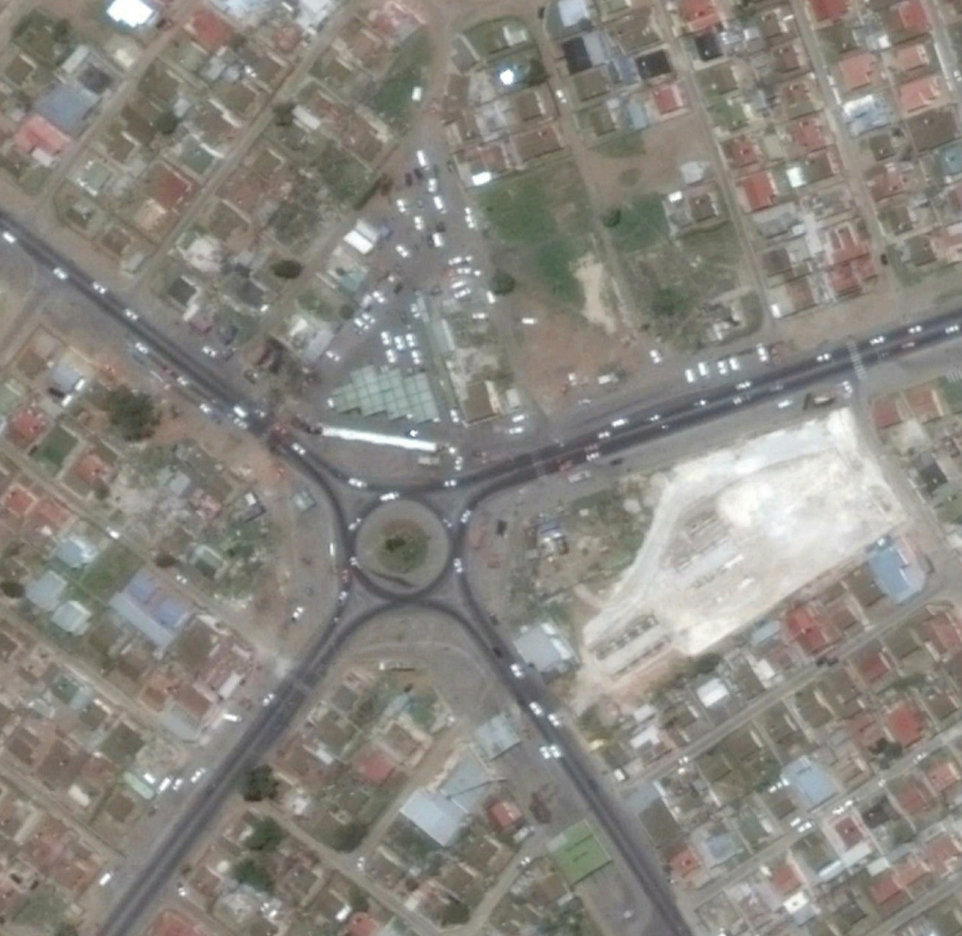
PLANNING AND MAPPING/FOOTPRINT

Noli Square redevelopment proposal

